# Lab-11-2: Containers

# Objectives

* Create and Manage Docker Containers
* Deploy Docker images

--------------------------------------------------------------------------------------------------

**Today:**

Login to your ubuntu installation (either locally, through Azure/AWS instance)

**Task1: Create and Run Container**

1. Setup docker
2. Run docker

Setup Docker

---------------------------------------

* sudo apt-get install docker.io
* add a new user named ‘conuser’ (hint: useradd command)
* add ‘conuser’ to ‘sudo’ group (hint: use usermod command)

Q1. What is the name of the group that docker created?

Ans: was not able to find this – the current way of installing

* Check if docker is running with
  + sudo docker info
* run a new container
  + sudo docker run -it ubuntu /bin/bash

Q2. What does the i and t options do in the above line?

Ans: -i = interactive (keep STDIN open even if not attached) -t = tty (allocate a pseudo=TTY)

Q3. What are the processes running on the container?

Ans:

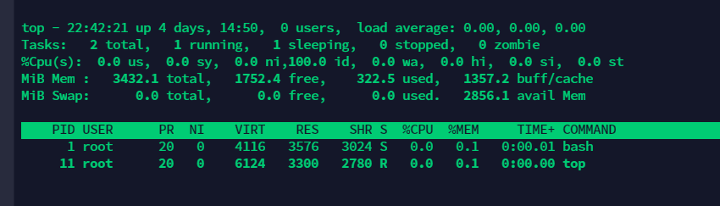

Q4. What are the ip addresses inside the container?

Ans:

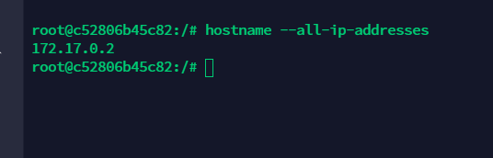

Q5. Compare the above with the host’s processes and ips. (Hint: exit and run top)

Ans:

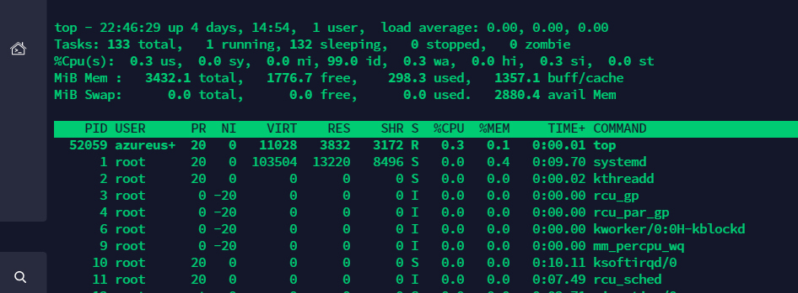

* list, inspect, stat the containers on the systems
  + sudo docker ps -a

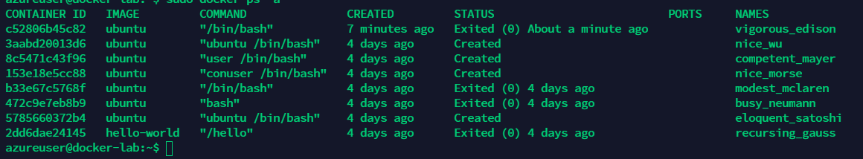

* + sudo docker inspect <containername>

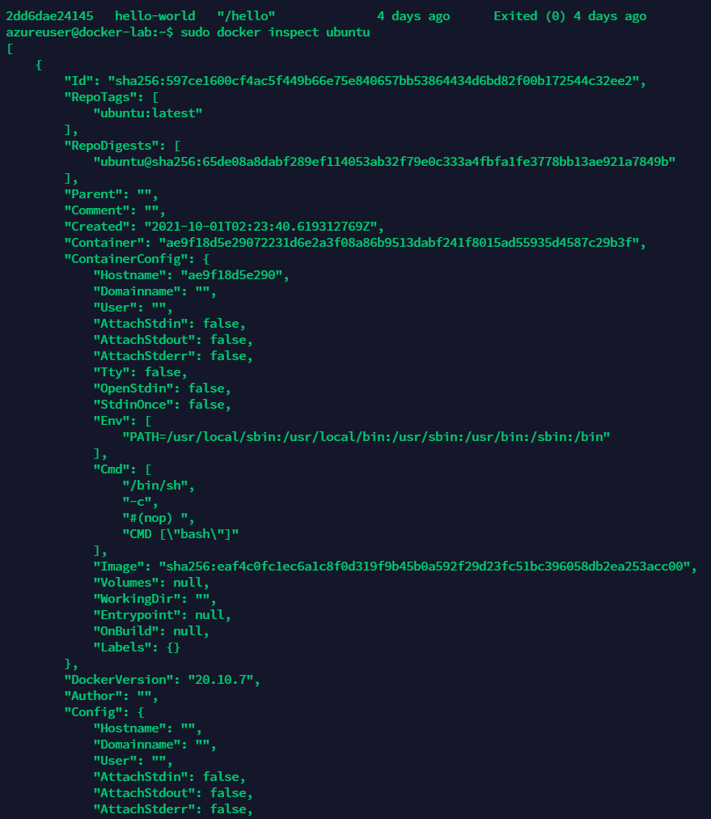

* + sudo start <containername>

Q5. What is the command to attach to the container?

Ans: sudo docker attach _containerName_ || _containerID_

**Task 2: Use Docker images**

1. Download docker images
2. Launch docker images from user’s repo

Docker run command downloads a container image if necessary and then runs it.

However, if we just want to download an image (not run it instantly) we can use the docker ‘pull’ command.

* Download Debian jessie image
  + sudo docker pull Debian:jessie

Q6. What is the command to download the latest Debian image?

Ans: sudo docker pull debian:latest

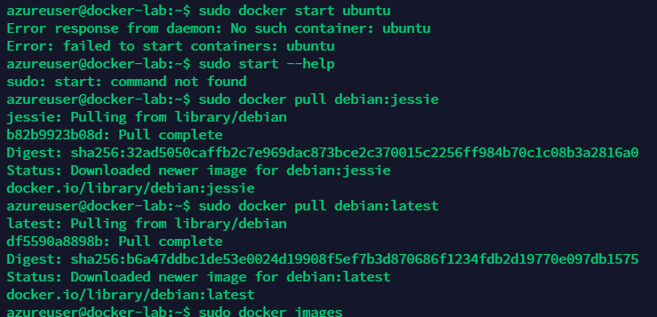

List the images on the system

* + sudo docker images

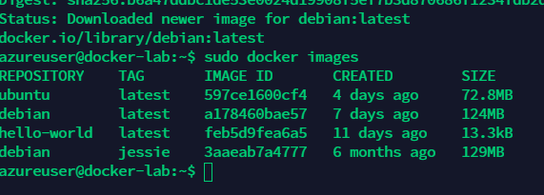

Q7. From where did docker downloaded the images?

Ans: Docker Hub

* Search docker hub for wordpress
  + sudo docker search wordpress

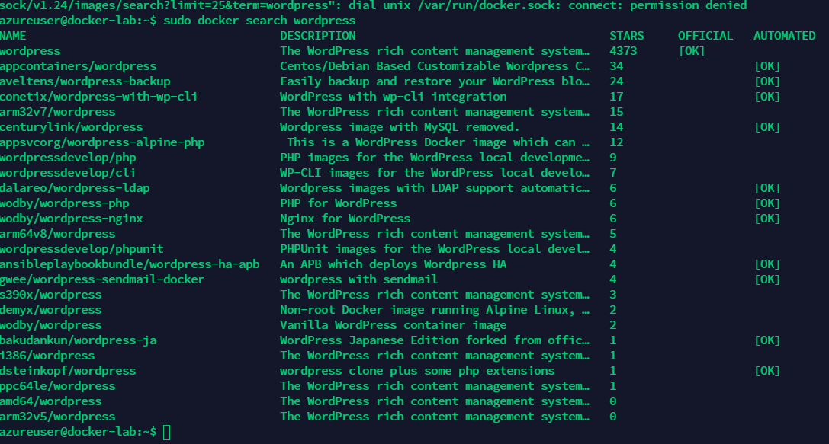

* Download docker image from user’s repo

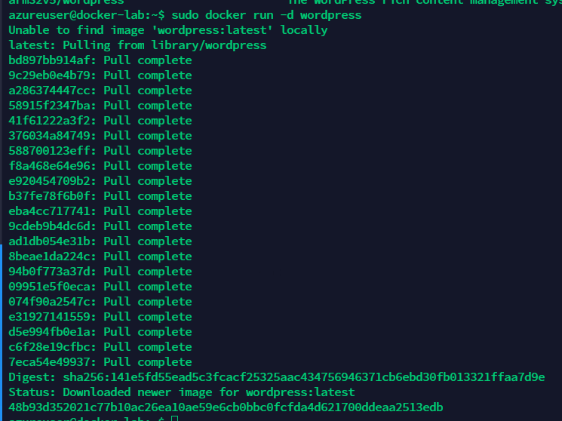

* + sudo docker run -p 80:80 -p 2222:22 --name wordpress -d tlongren/docker-wordpress-nginx-ssh:stable

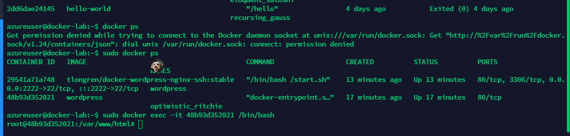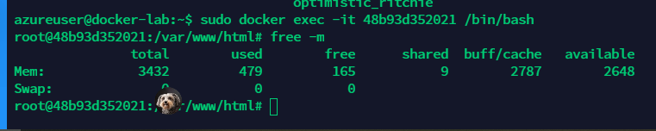

Q8. What is the purpose of -p and its parameters in the above command?

Ans: maps the local port to the port used in the docker container

Q9. Can you ssh into the container? Whats the command?

Ans: sudo docker exec -it 48b93d352021 /bin/bash

Q10. Will you be able to use your browser to get to the container? Post screenshot

Ans:

